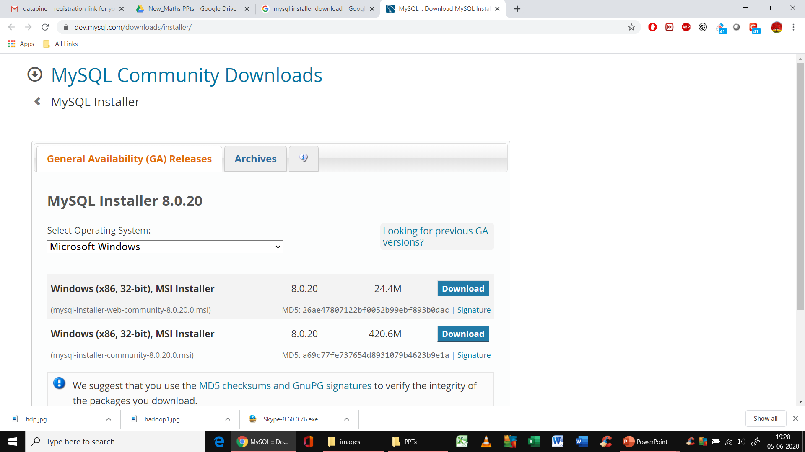

Select the second link with 420.6 M size

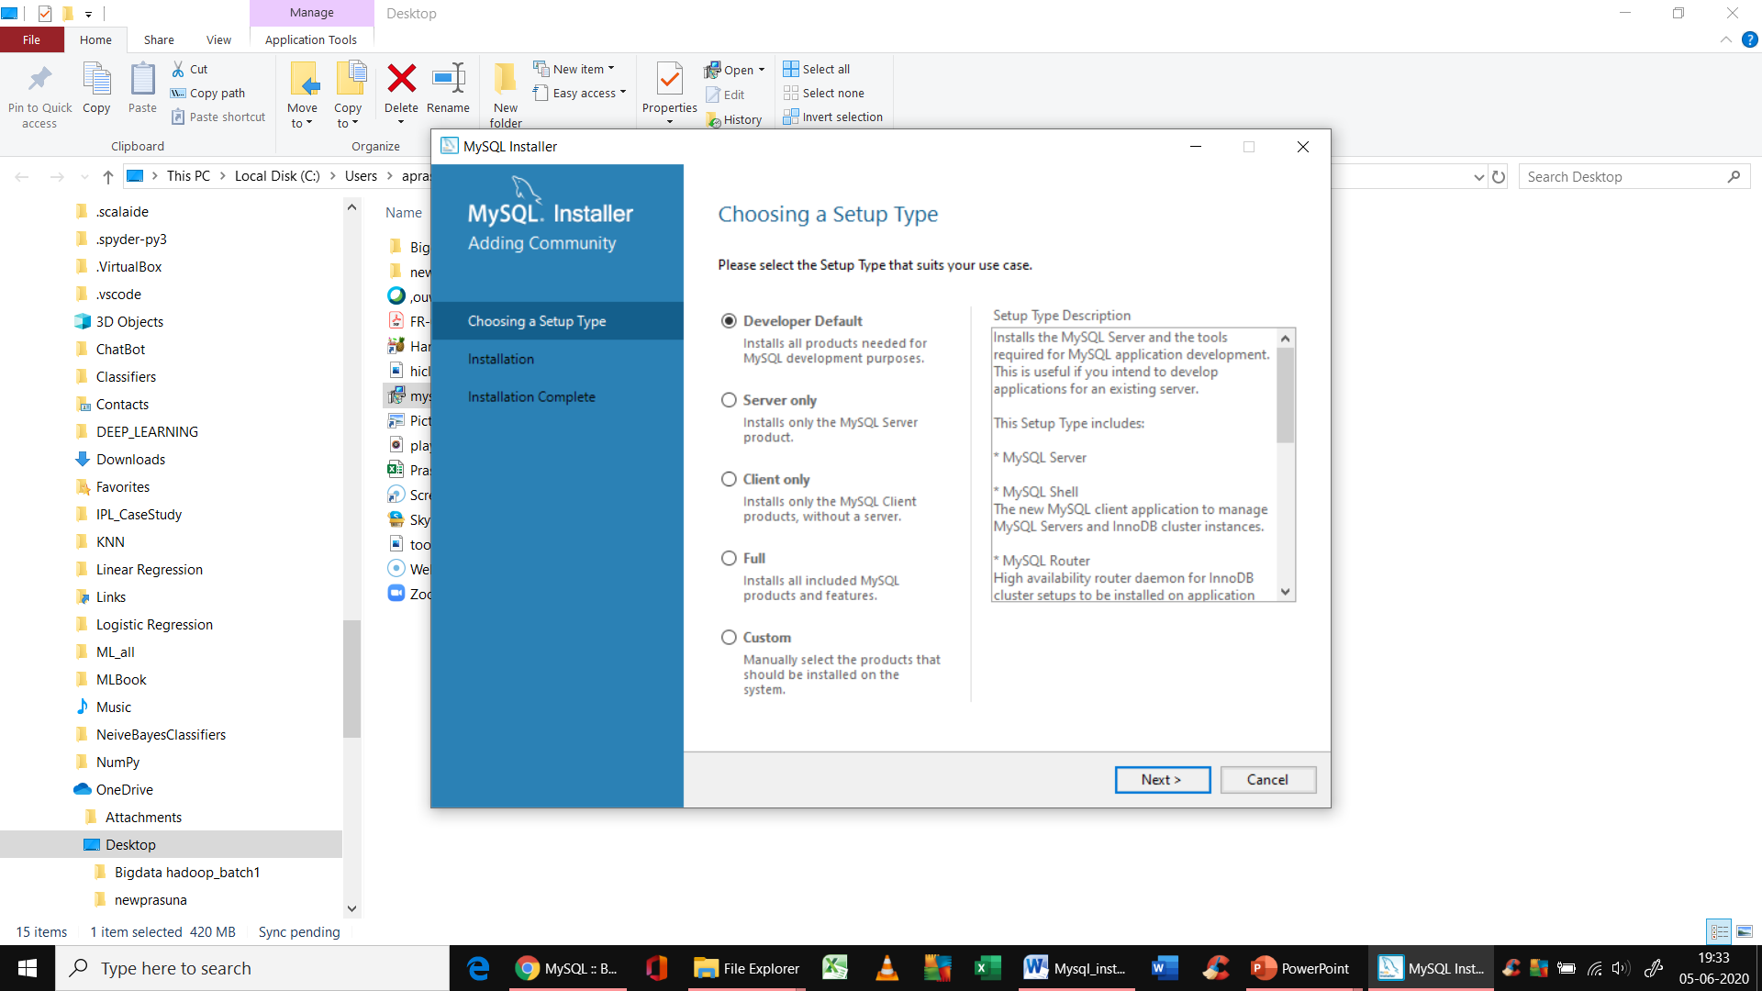

Select developer default option only and click next

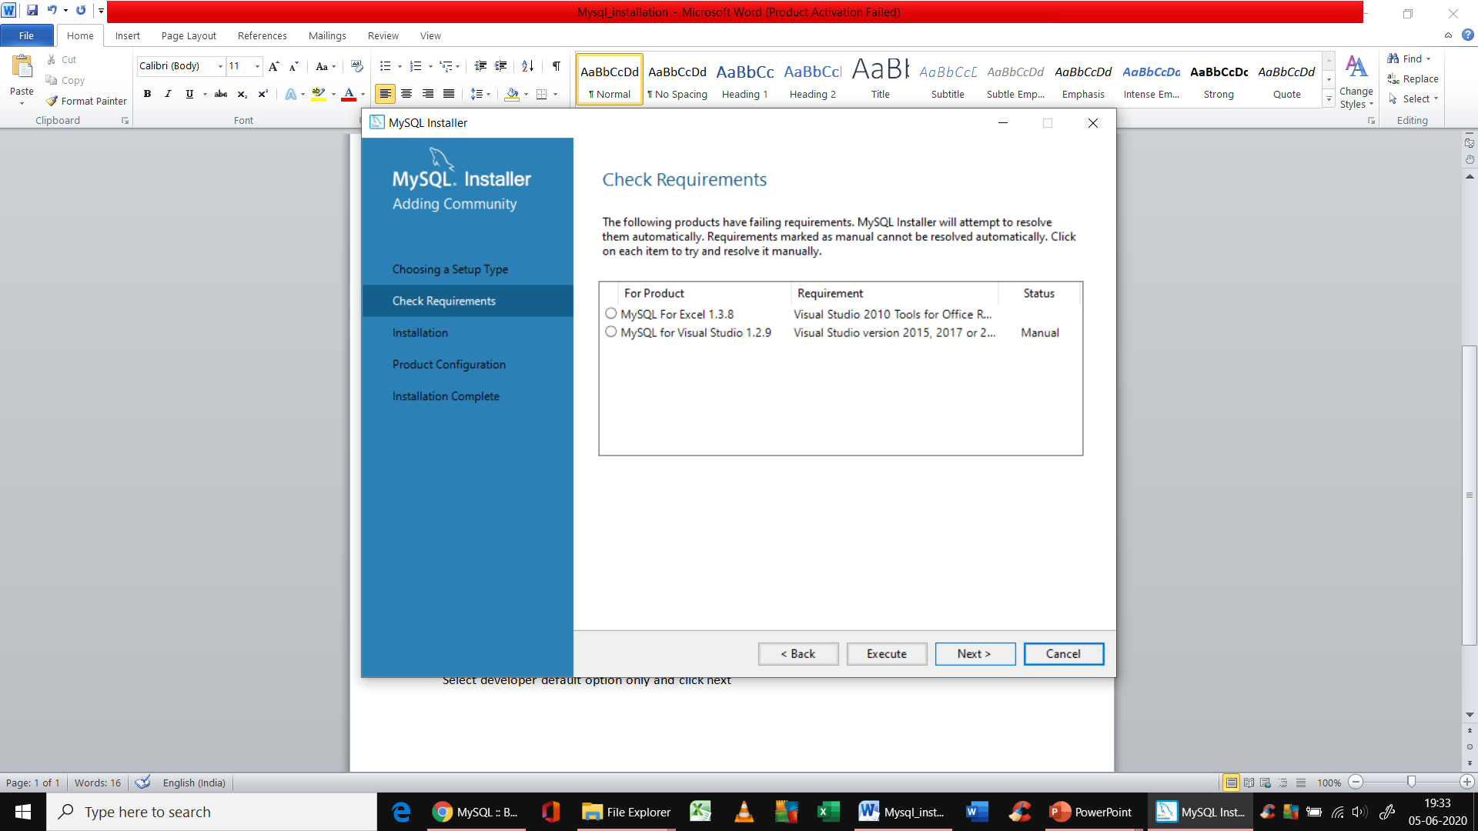

You can click next simply without selecting anything here

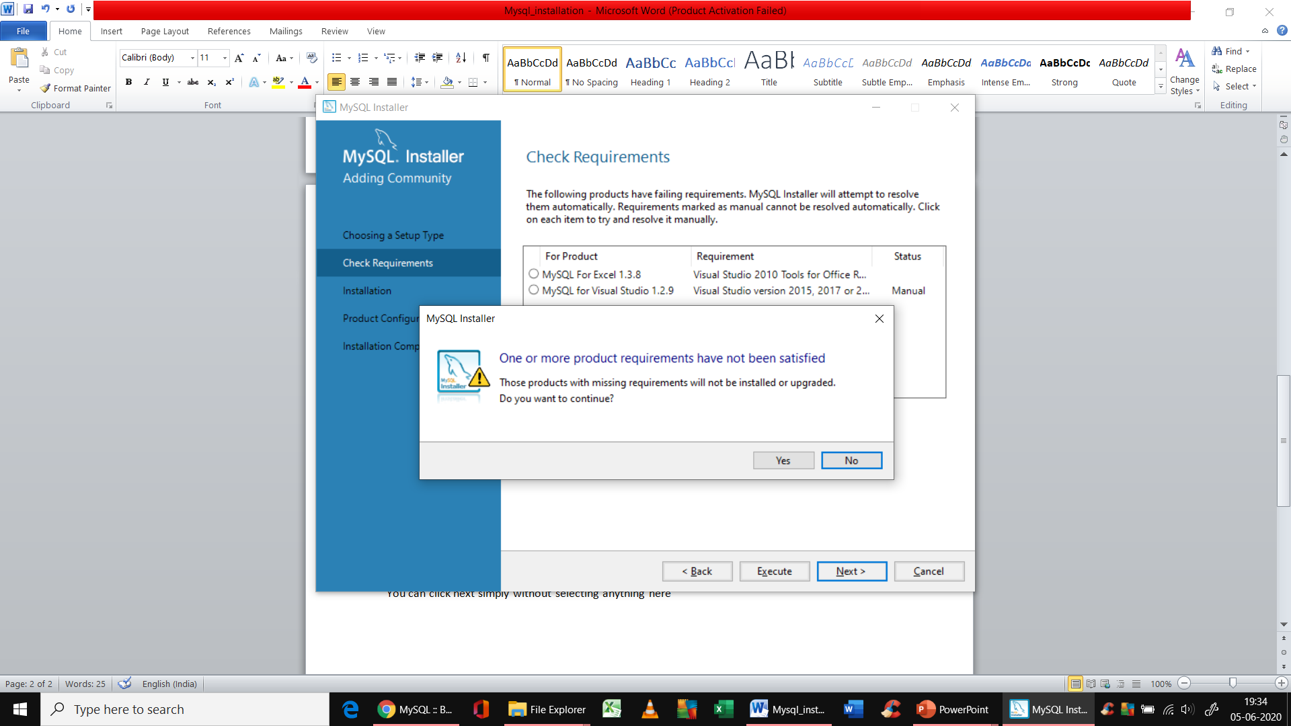

Click ‘yes’ here



Next window

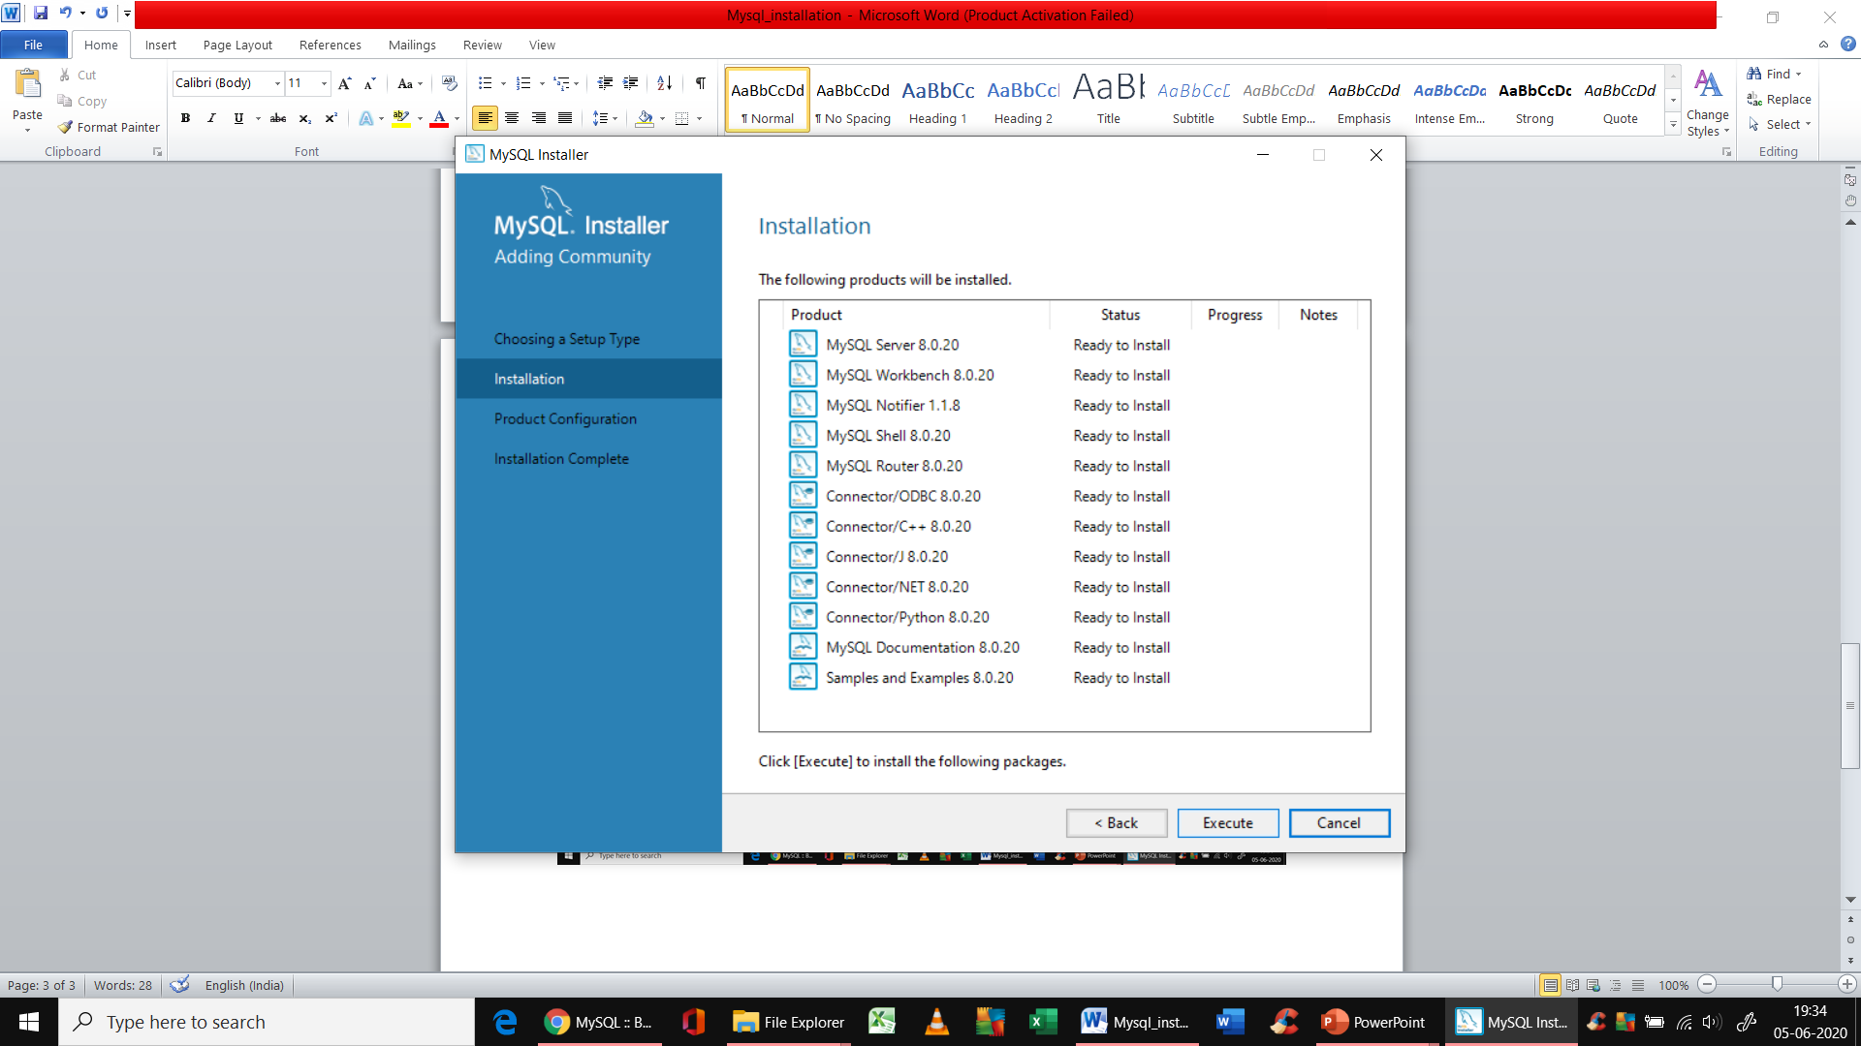

Click on execute

It takes sometime to install

After successful installation, you should see something like this.

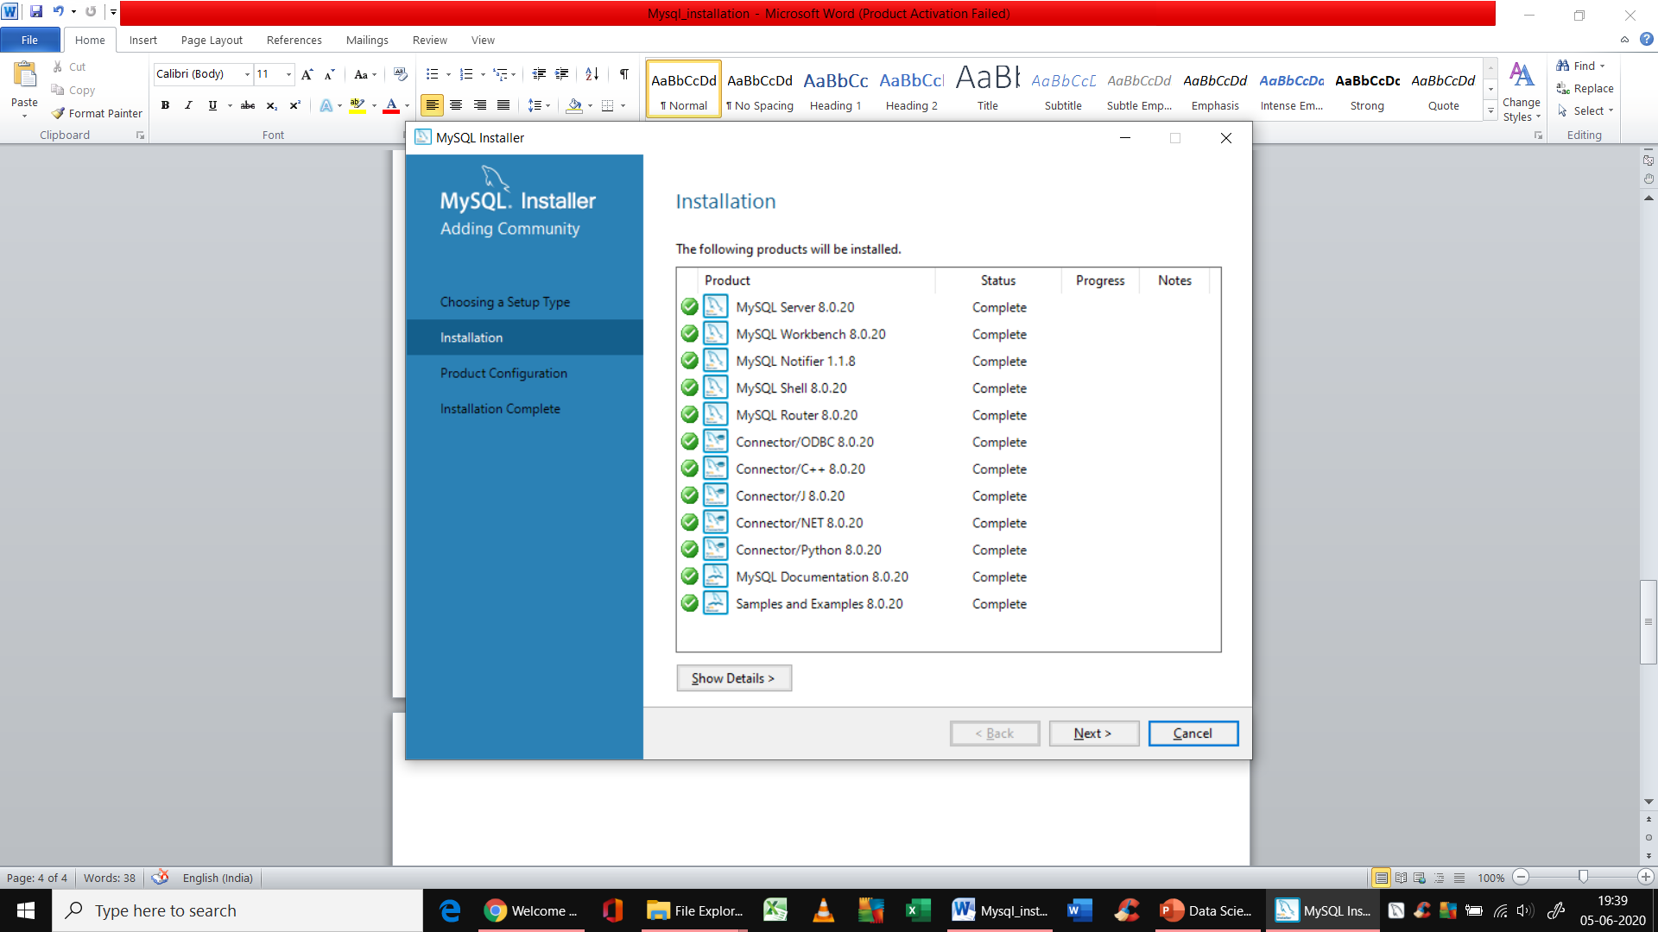

Next window would be

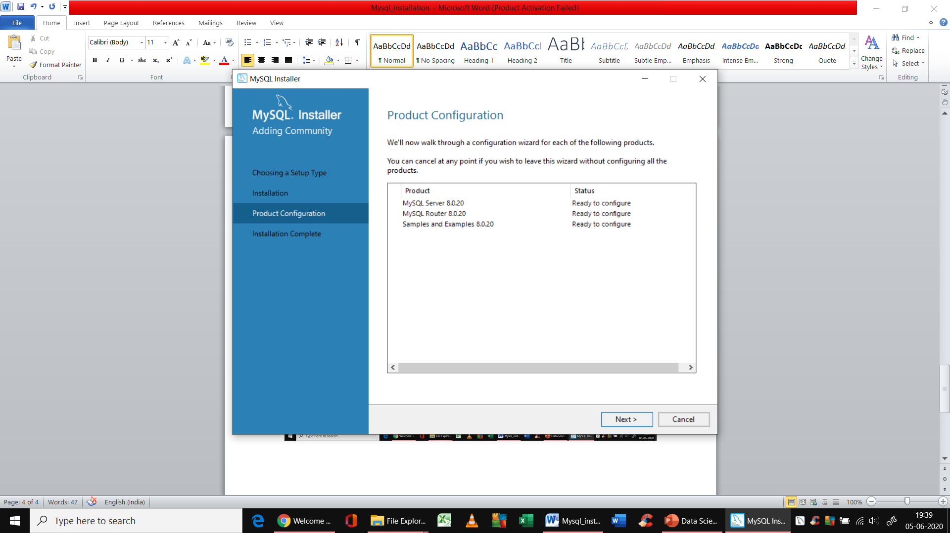

Click next

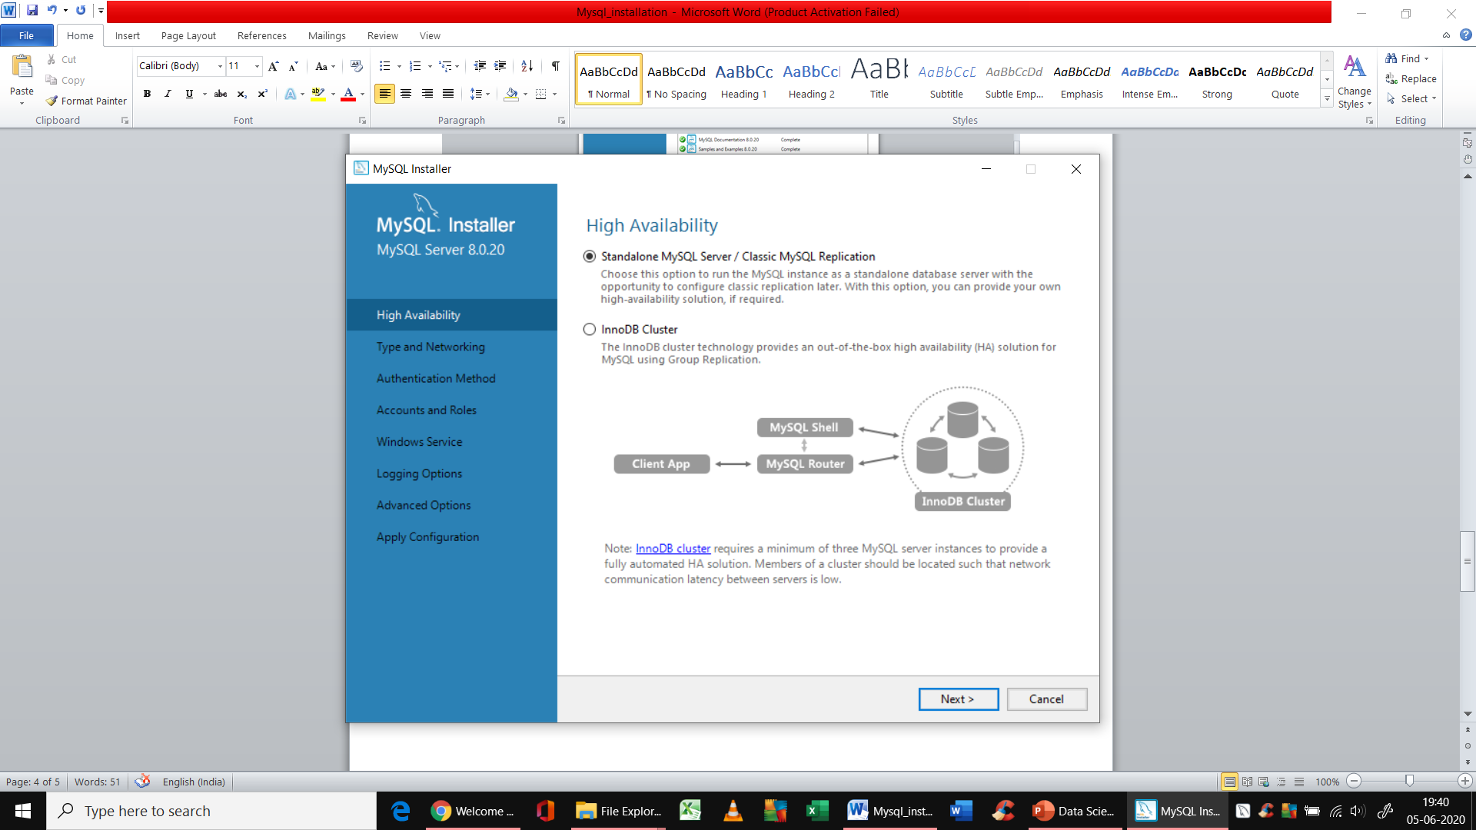

Select 1st option

You will get the below screen

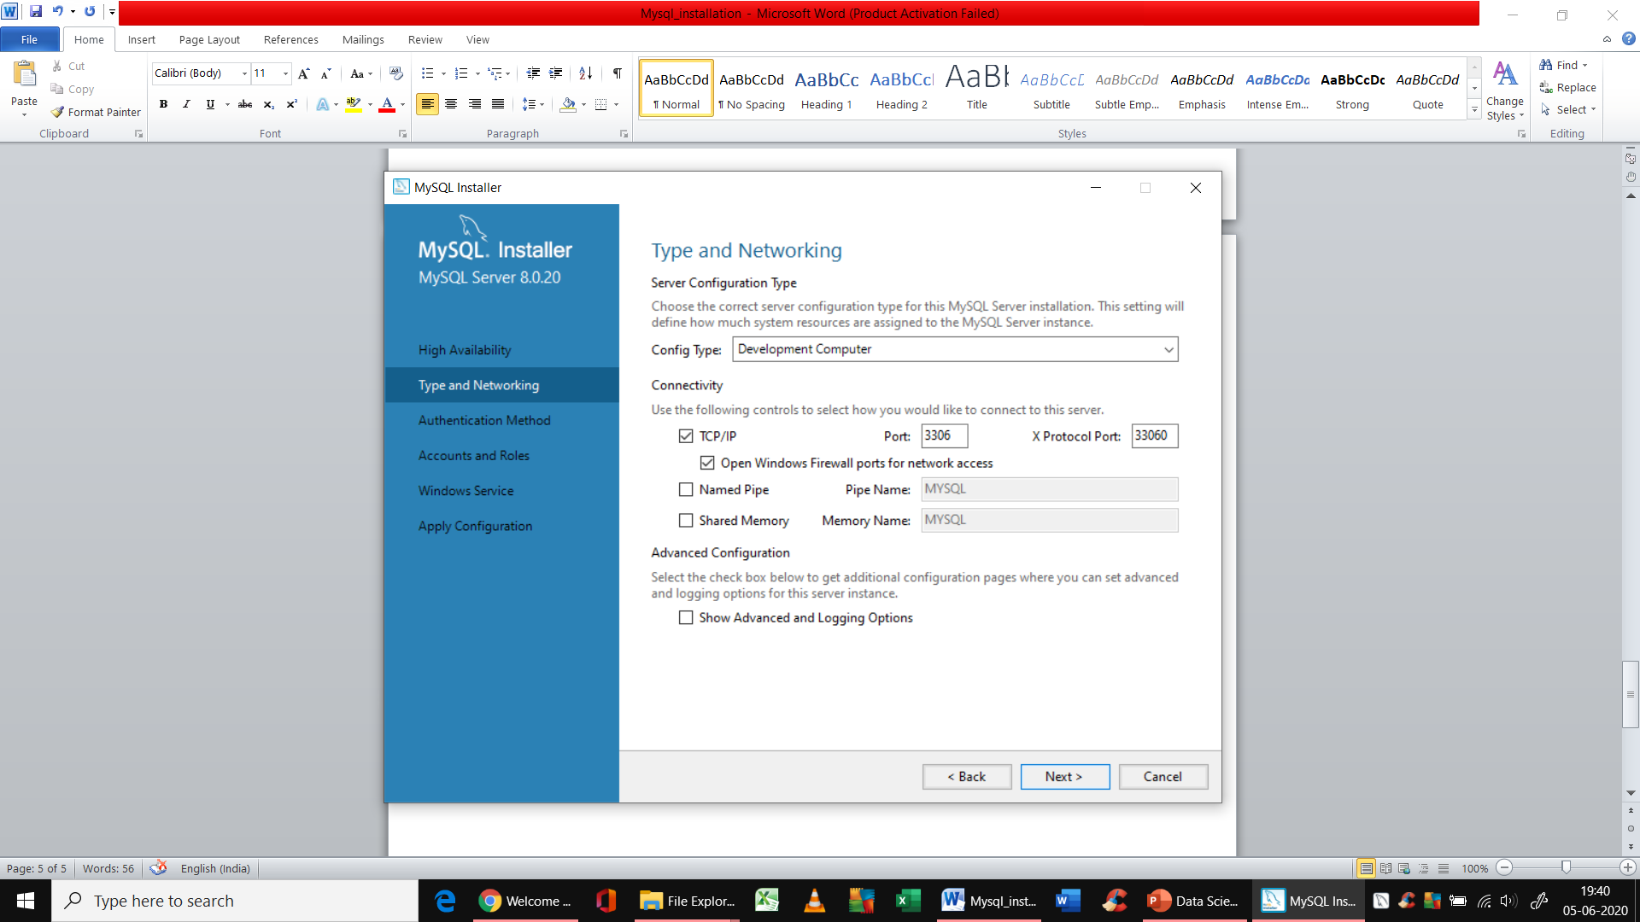

In next window, select 1st option for authentication method.

Give userid and pwd here

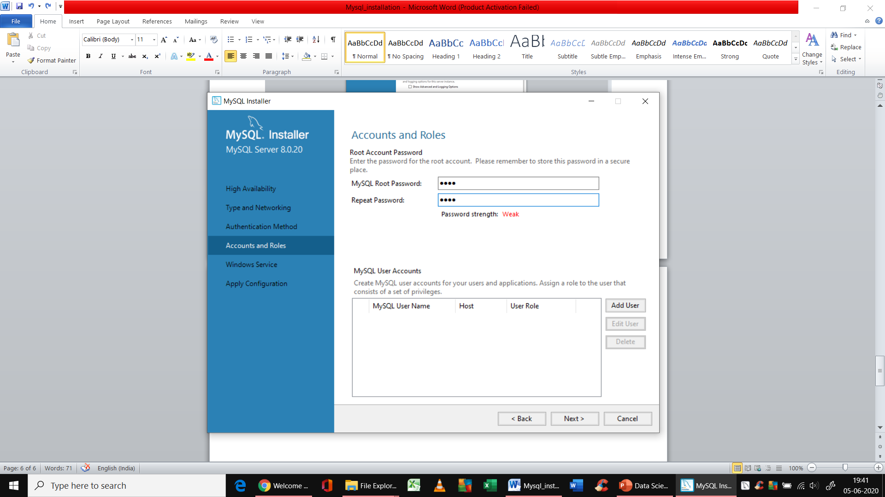

And click next

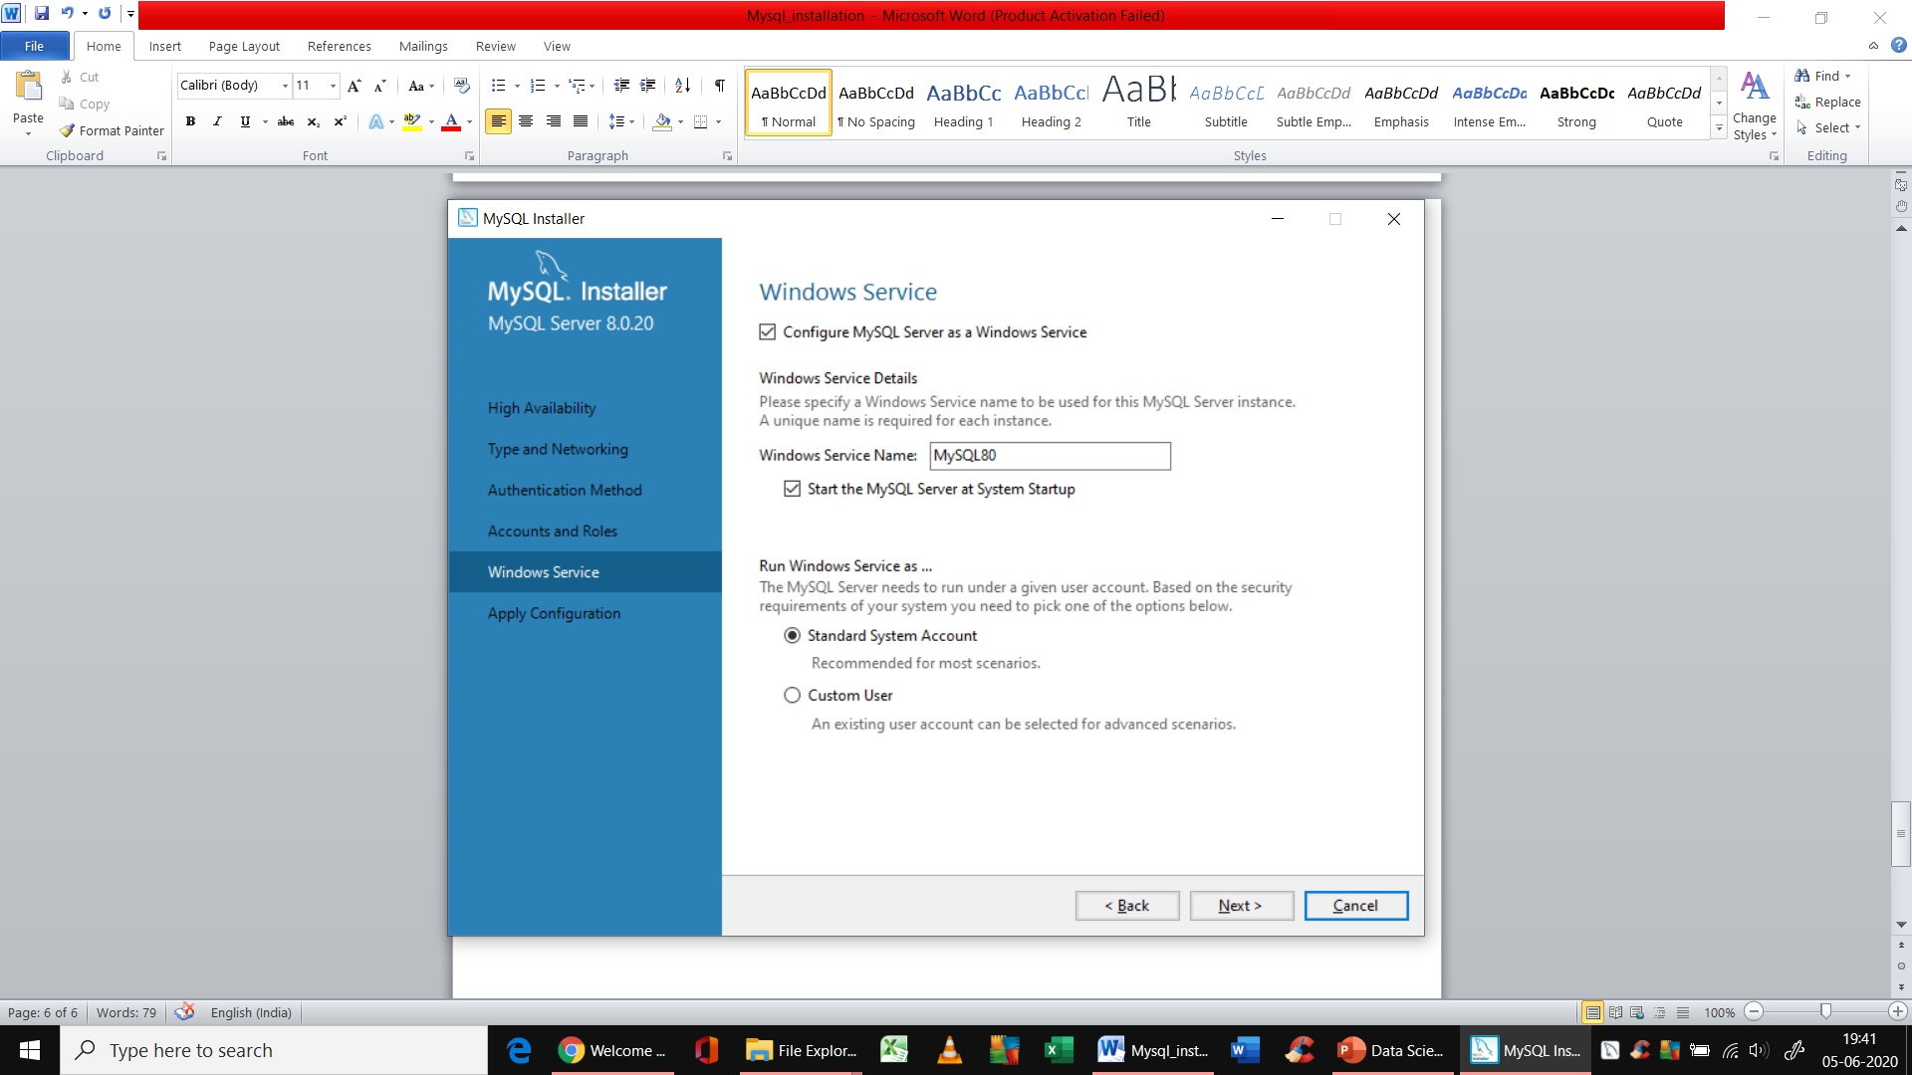

**And in the last window, click on execute again**

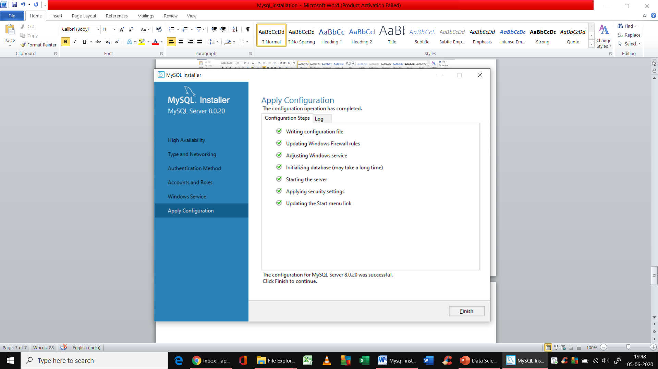

**Click finish -> next -> next you will land in the below page**

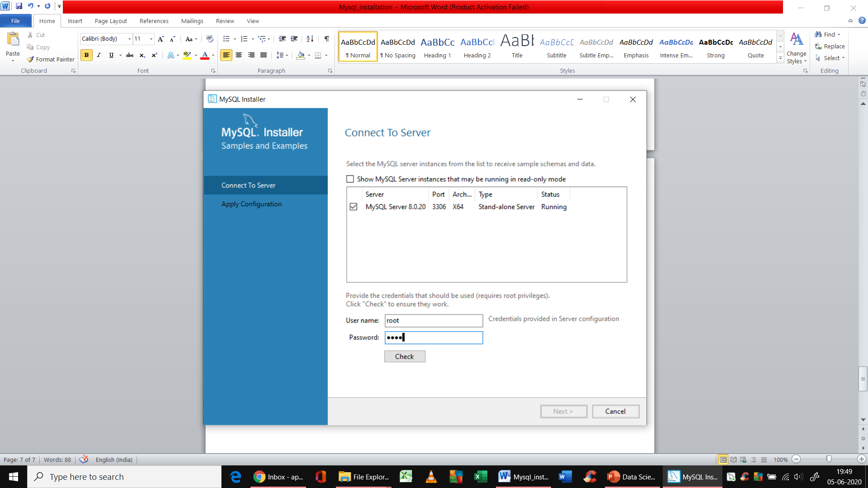

**Give your username and password and check the connection**

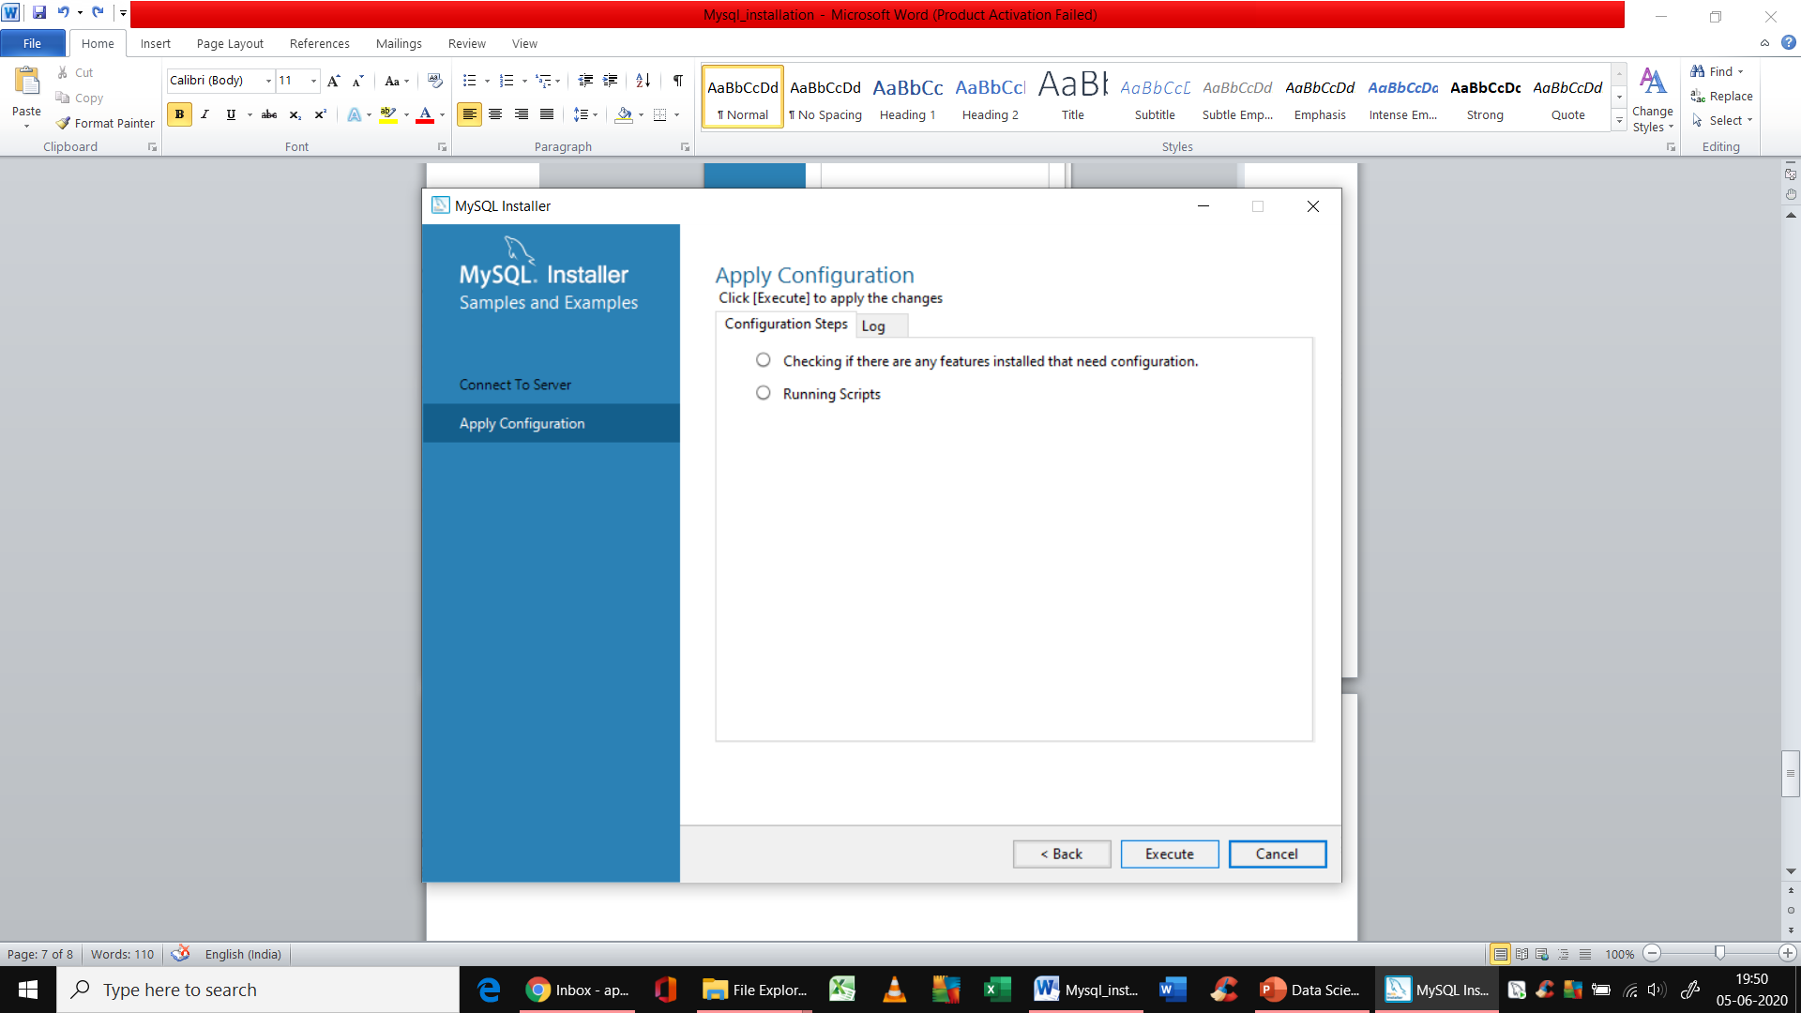

**Click on execute again**

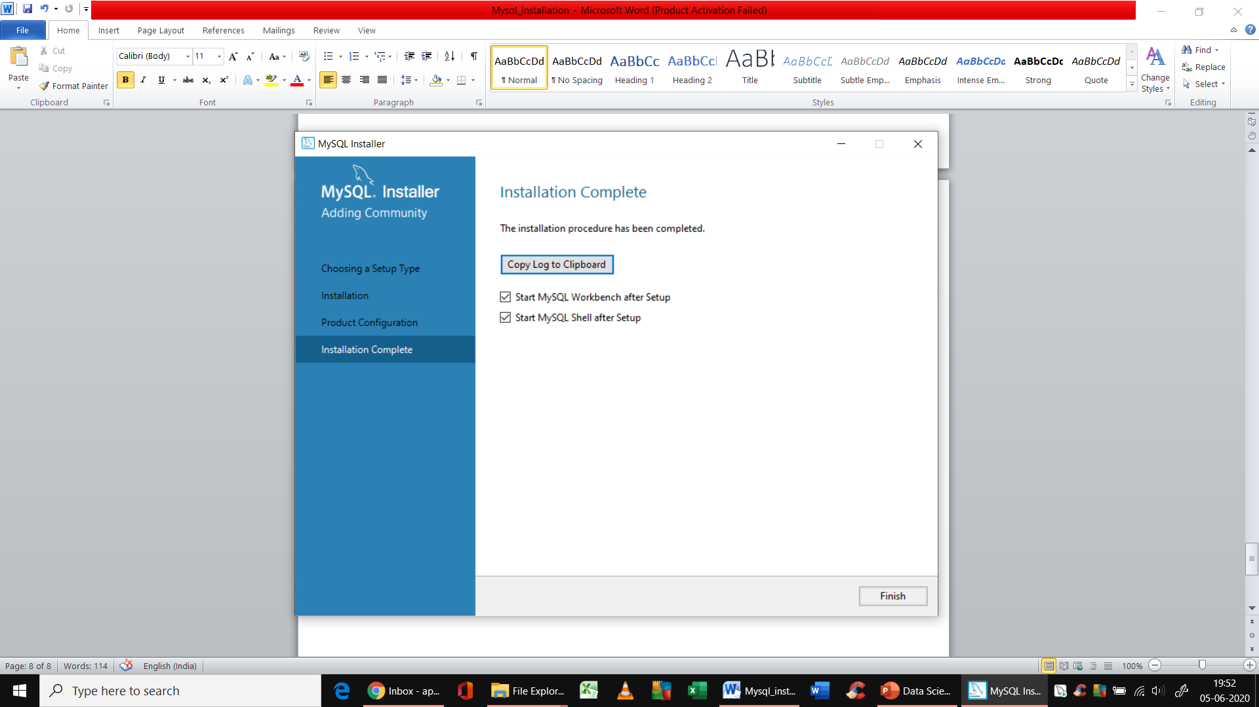

**Click next->next-> and click on finish**

**You will see both Mysql CLI like below**

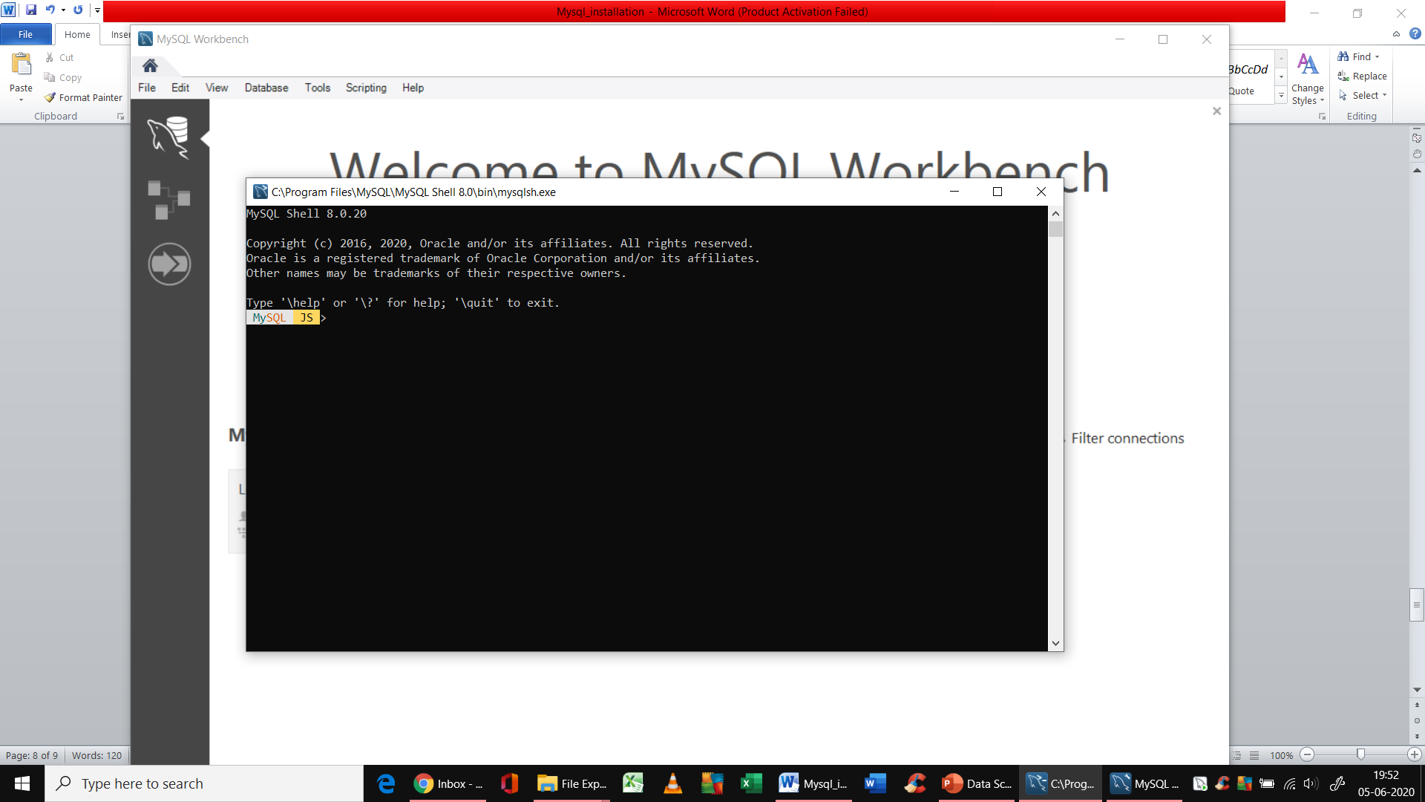

**As well as GUI as below**

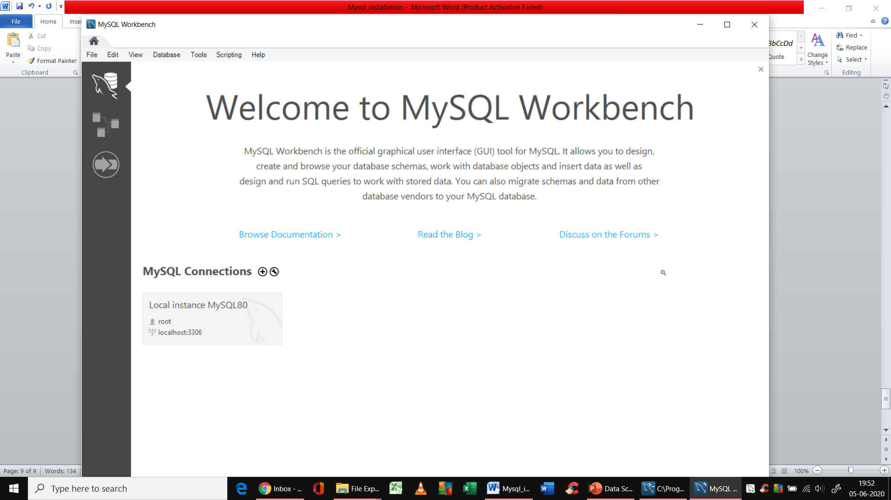

**You can connect in GUI using id/pwd you used while configuring and use this.**

